Rome Standard Wall Hung Vanity

**Product Code:** ROM94W-MW

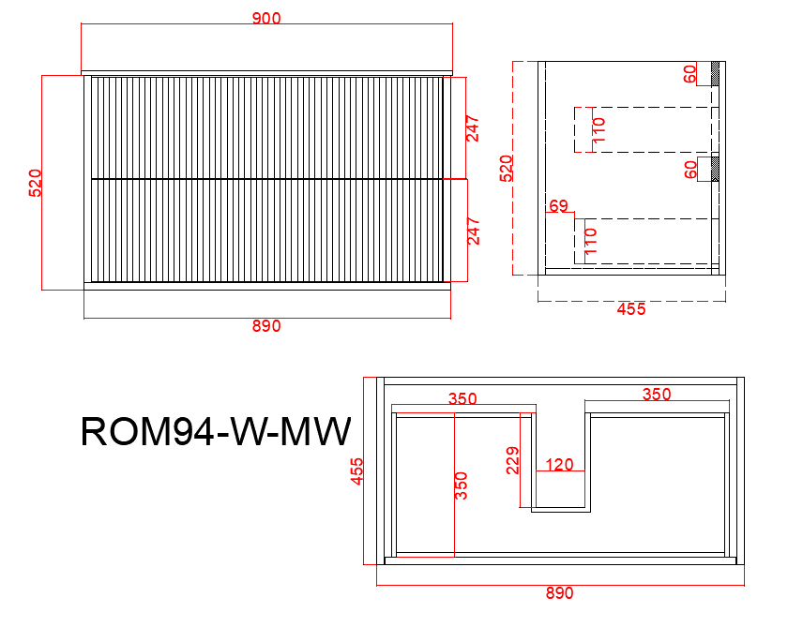

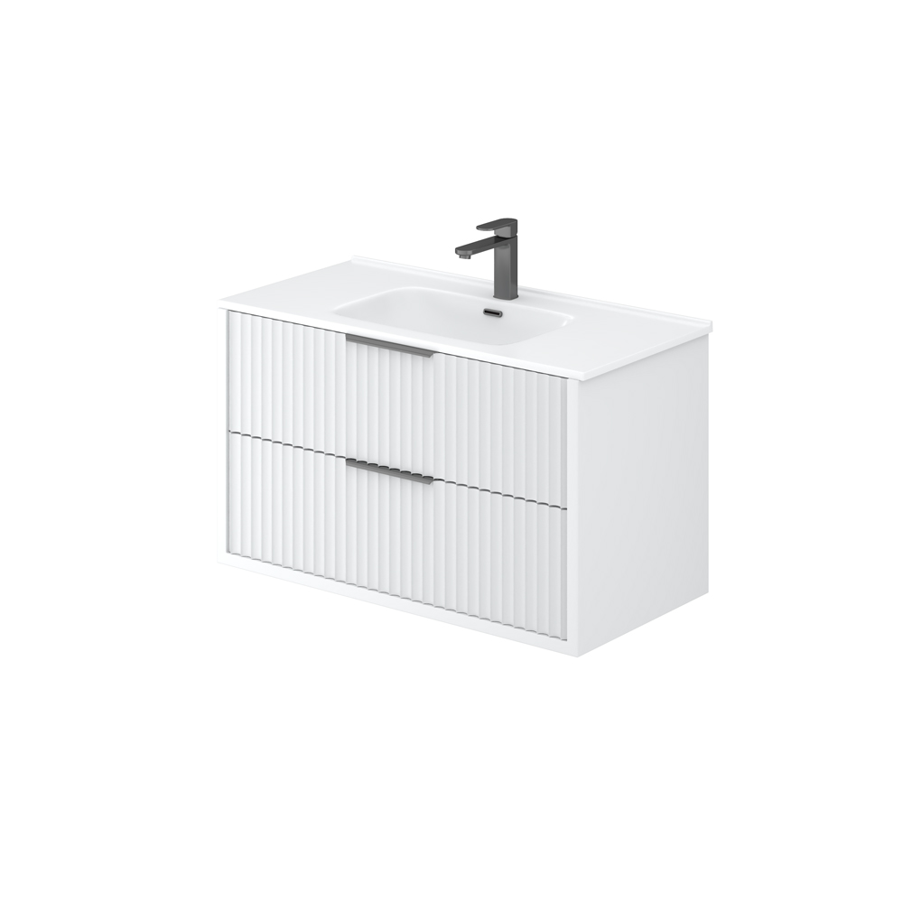

**Specification:**

Material: PVC construction

Finish: Matte white / Matte black

Dimension: 900*455*520mm

Soft closing drawers

Handle - Suggested:

CAHDL200-BG / CAHDL200-MB

Handle options:

Size - 150mm / 200mm / 250mm Colour - matte white / matte black / gum metal / brushed gold / brushed nickel

Vanity top options:

Standard ceramic top - PC9046

Olivia ceramic top - 90BT / D900B / OMW900 / OMB900

Poly top - POLY9046B

Stone top (with choices of tap hole and waste hole position) -

ABW94 / ABT94 / ASNOW94 / AWSP94 / AGSP94 / AGalaxyB900 / ACar94 / ANmq94