Rome Standard Wall Hung Vanity 

**Product Code:** ROM74W-MW

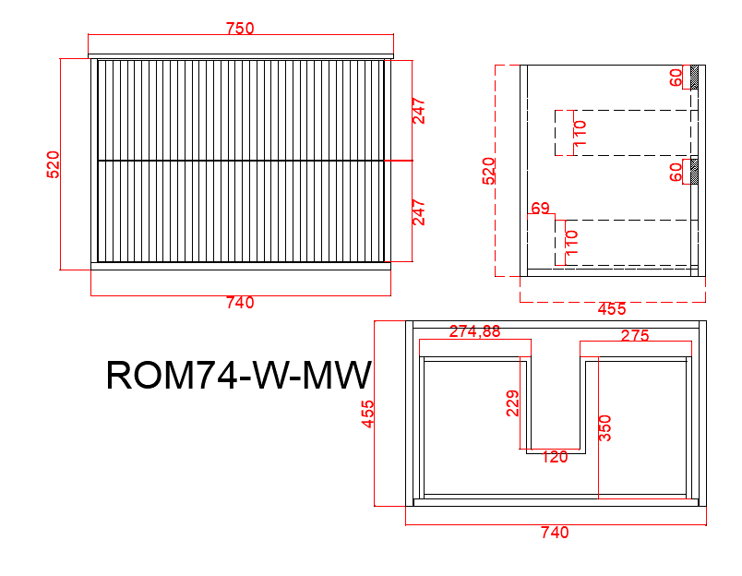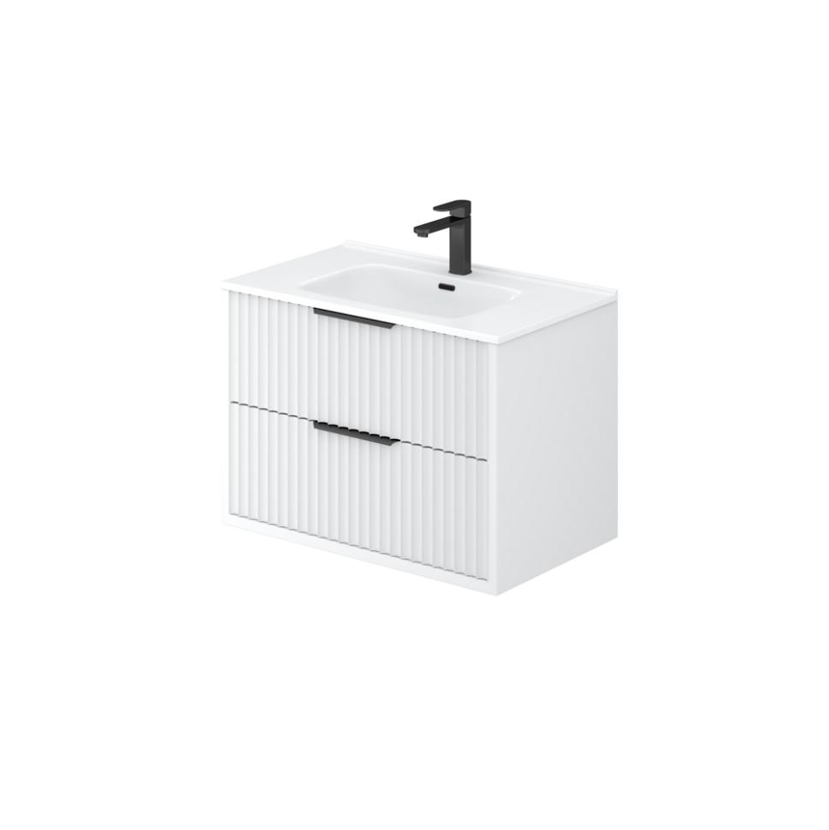

**Specification:**

Material: PVC construction

Finish: Matte white / Matte black

Dimension: 750*455*520mm

Soft closing drawers

Handle - Suggested:

CAHDL150-BG / CAHDL150-MB

Handle options:

Size - 120mm / 200mm / 250mm / 300mm

Colour - matte white / matte black / gum metal / brushed gold / brushed nickel

Vanity top options:

Standard ceramic top - PC7546

Olivia ceramic top - 75BT / D750B / OMW750 / OMB750

Poly top - POLY7546B

Stone top (with choices of tap hole and waste hole position) -

ABW74 / ABT74 / ASNOW74 / AWSP74 / AGSP74 / AGalaxyB750 / ACar74 / ANmq74