
Rome Standard Wall Hung Vanity

Product Code: ROM64W-MW

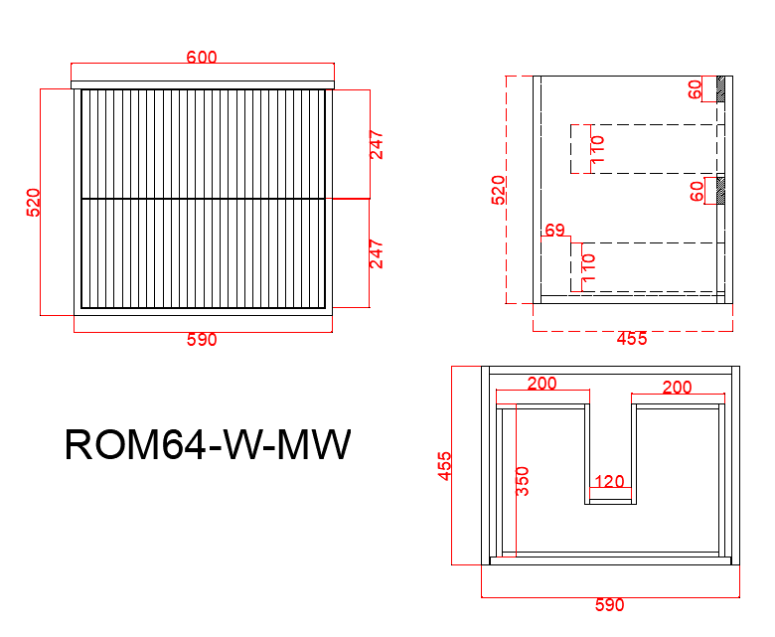
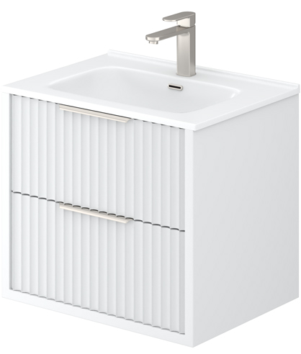

Specification:
Material: PVC construction
Finish: Matte White / Matte Black
Dimension: 600*450*520mm
Soft Closing Drawer

Handle - Suggested:
CAHDL120-BG / CAHDL120-MB

Handle options:
Size - 150mm / 200mm / 250mm / 300mm
Colour - matte white / matte black / gun metal / brushed gold / brushed nickel

Vanity top options:
Standard ceramic top - PC6046
Olivia ceramic top - 60BT / D600B / OMW600 / OMB600
Poly top - POLY6046B
Stone top (with choices of tap hole and waste hole position) -
ABW64 / ABT64 / ASNOW64 / AWSP64 / AGSP64 / AGalaxyB600 / ACar64 / ANmq64

