Rome Standard Wall Hung Vanity

**Product Code:** ROM64W-MW

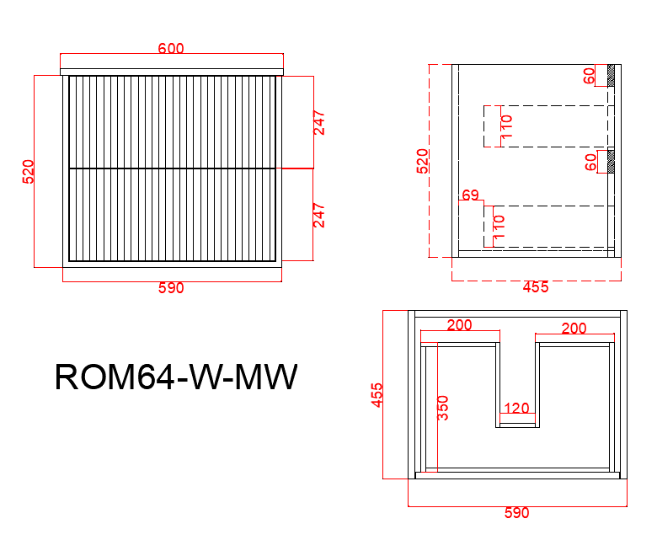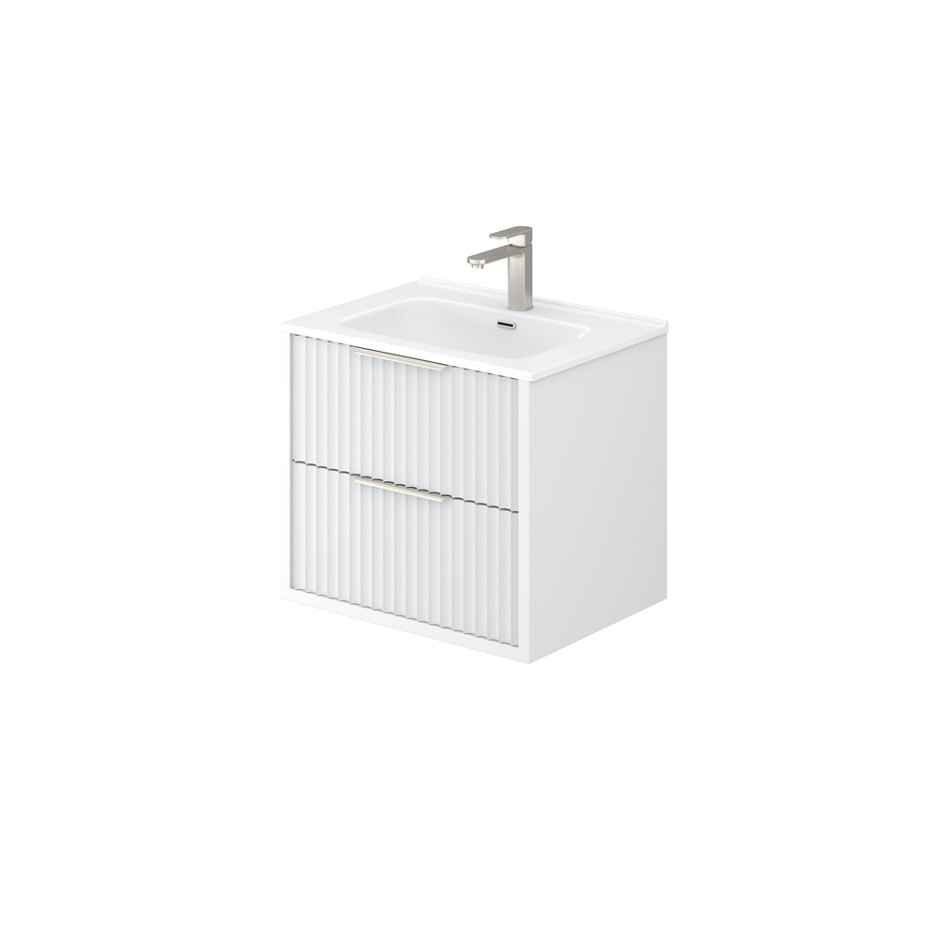

**Specification:**

Material: PVC construction

Finish: Matte White / Matte Black

Dimension: 600*450*520mm

Soft Closing Drawer

Handle - Suggested:

CAHDL120-BG / CAHDL120-MB

Handle options:

Size - 150mm / 200mm / 250mm / 300mm

Colour - matte white / matte black / gun metal / brushed gold / brushed nickel

Vanity top options:

Standard ceramic top - PC6046

Olivia ceramic top - 60BT / D600B / OMW600 / OMB600

Poly top - POLY6046B

Stone top (with choices of tap hole and waste hole position) -

ABW64 / ABT64 / ASNOW64 / AWSP64 / AGSP64 / AGalaxyB600 / ACar64 / ANmq64