Rome Standard Wall Hung Vanity

**Product Code: ROM1550W-MW**

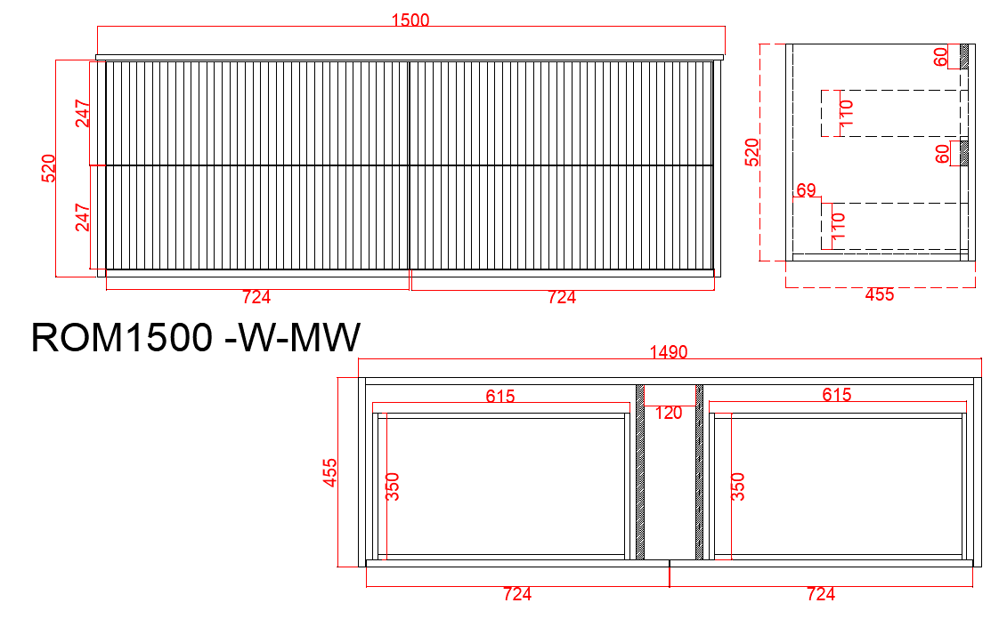

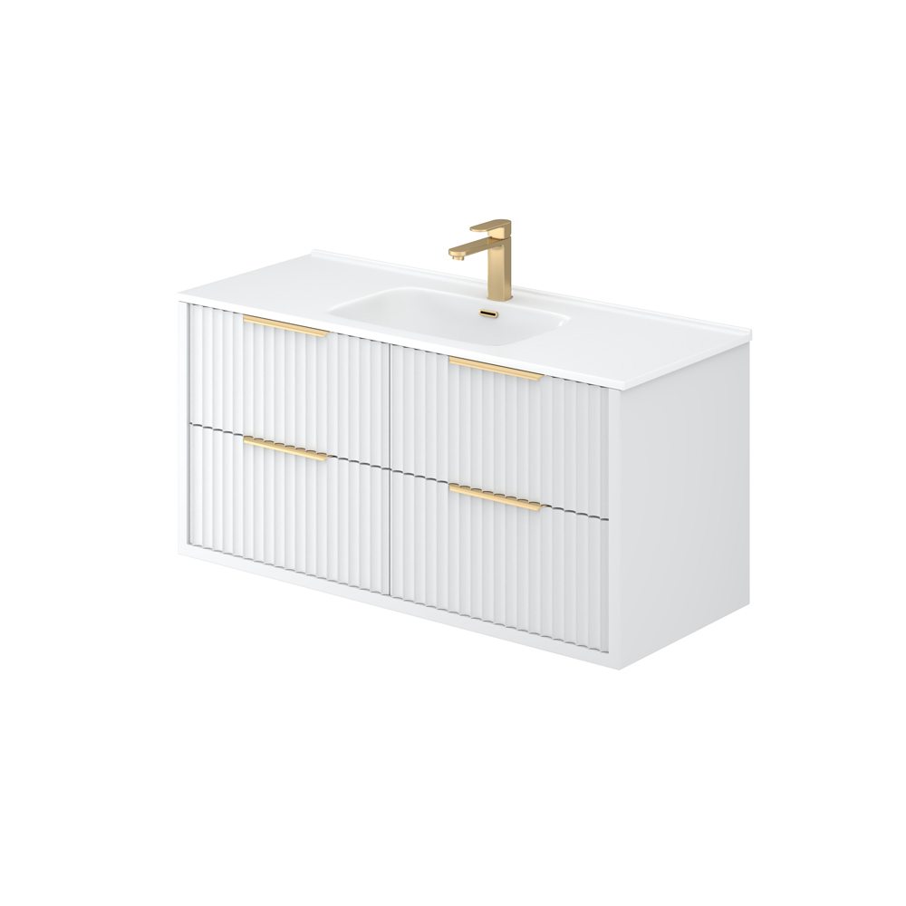

**Specification:**

Material: PVC construction

Finish: Matte white / Matte black

Dimension: 1500*455*520mm

Soft Closing Drawers

Handle - Suggested:

CAHDL150-BG / CAHDL150-MB

Handle options:

Size - 150mm / 200mm / 250mm

Colour - matte white / matte black / gum metal / brushed gold / brushed nickel

Vanity top options:

Standard ceramic top - PC1546 (Single bowl) / PC1546D (Double bowl)

Stone top (available for undermount or above counter)