Rome Standard Wall Hung Vanity

**Product Code:** ROM1200W-MW

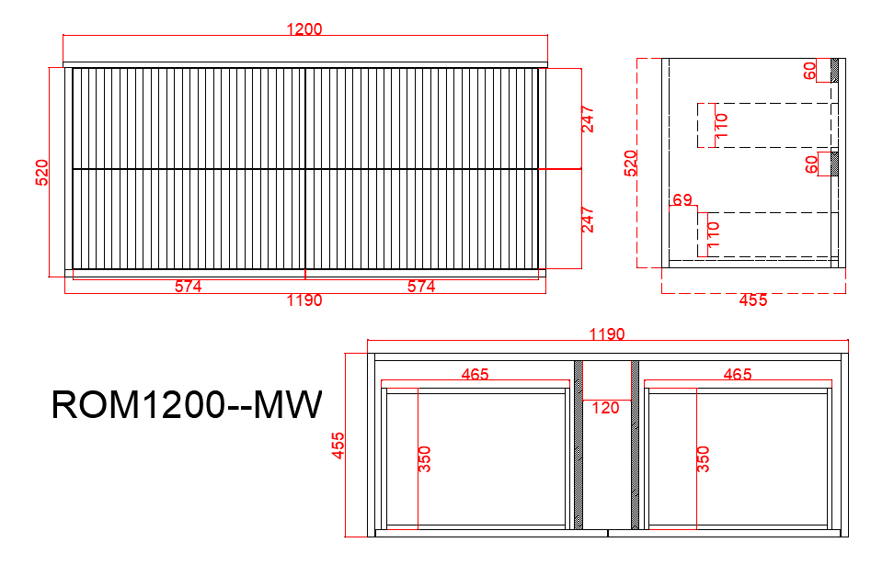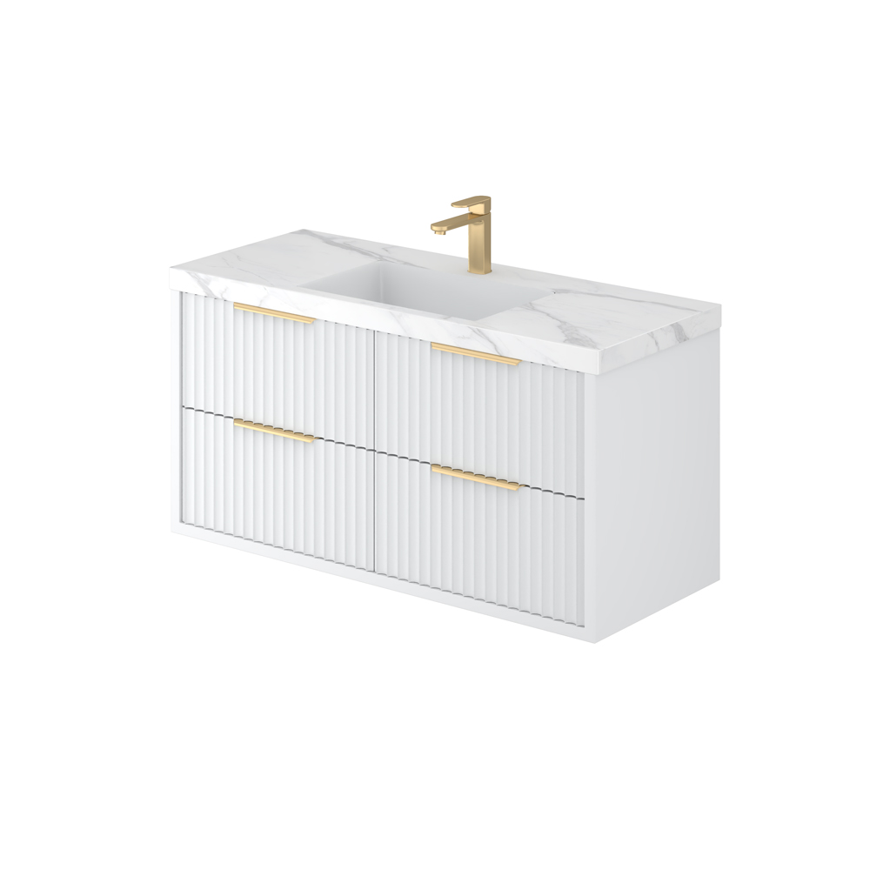

**Specification:**

Material: PVC construction

Finish: Matte white / Matte black

Dimension: 1200*460*500mm

Soft Closing Drawers

Handle - Suggested:

CAHDL250-BG / CAHDL250-MB

Handle options:

Size - 120mm / 150mm / 200mm / 300mm

Colour - matte white / matte black / gum metal / brushed gold / brushed nickel

Vanity top options:

Standard ceramic top - PC1246

Olivia ceramic top - 120BT / D1200B / OMW1200 / OMB1200

Poly top - POLY1246B

Stone top (with choices of tap hole and waste hole position) -

ABW124 / ABT124 / ASNOW124 / ACar124 / ANmq124